Minutes
Jesse D. Scott
School Organizational Team Meeting
Library
September 25, 2019
2:45 p.m. – 4:15 p.m.

School Organizational Team Members:

Callum, Hiller – Chair-P
Diane Mangum - Vice Chair-P
Gloria Roe – Secretary-P
Alma Macias - Parliamentarian-P

Dana Roseman-p
Melanie McCraney-p
Monica Wesley
Vergil Smith

Topics to be Discussed:
A. Welcome & Roll Call- everyone introduced their selves
to all others present.
B. Budget Update
a. Discussed changes to budget and where we are with
open positions and long term subs.
C. CSI Indication on NSPF / School Performance Plan
a. Discussed NSPF score of a one and our CSI
designation.
b. Discussed our goals on the School Performance Plan
and how we can help meet those strategic goals.
D. F.A.C.E.S. classes
a. Discussed classes that we might want to have at
school for parents.
E. Next Meeting October 23, 2019

Minutes
Jesse D. Scott
School Organizational Team Meeting
Library
October 23, 2019
2:45 p.m. – 4:15 p.m.

School Organizational Team Members Present:
Diane Mangum
Dana Roseman: Principal
Others Present:
Elyse Gresnick-Smith: Community Partner
Miyonna Jones: Parent
Christi Davis: 21st Century Campus Coordinator

Topics Discussed:
- Welcome & Roll Call
Meeting called to order.
Everyone introduced themselves and told what their title/position was.
- Position Review (moved to next meeting due to not having enough members present)
  - Chair
  - Vice-Chair
  - Secretary
  - Parliamentarian
- Budgets
  - Review types
Reviewed 3 main types: Strategic, Title I and SB178 and what they are used for this year.
  - Leadership Program (moved to next meeting)
- CSI Designation
Discussed what CSI designation is Comprehensive Support and Improvement. We have A-Net working with us providing administrative coaching and mentoring, Data informed decision making, professional development.
- Title I Parent Notification Letter
Review the parent notification letter sent home and can be accessed on school website. Part of CSI designation/Title I guidelines.
- Data Share
Reviewed Data for Imagine Learning, Myon, Lexia, and STMath.
Imagine Learning – Progress to date
Above Level- 4%
On Grade Level-4%
Below Grade Level-92% (1year below 22% +2years below 70%)
Myon- Books Finished to date
K – 0
1 – 447
2 – 665
3 – 806
4 – 1,696
5 – 1,547
Lexia Usage this week
K – 59%
1 – 71%
2 – 73%
3 – 71%
4 – 63%
5 – 54%
STMath - usage Ave. Minutes last week
K – 25.9
1 – 31.8
2 – 40.2
3 – 43.0
4 – 143.3
5 – 72.3
- PBIS Rewards
Roseman showed app and explained that it will be used for rewards based on our four pillars: Be Responsible, Be Prepared, Respect Others, and Respect Property. Students can redeem points on Thursdays from student store. Program will be launched in November, 2019.
- Next Meeting November 20, 2019 at 2:45pm
Meeting Adjourned.

MINUTES
Jesse D. Scott
School Organizational Team Meeting
Library
November 20, 2019
2:45 p.m. – 4:15 p.m.

School Organizational Team Members:

Diane Mangum-present
Jennifer Spigel-present
Miyonna Jones-present
Open

Dana Roseman-present
Assistant Principal
Kennedith Marshall
Jennifer Orpilla

Topics to be Discussed:
- Welcome & Roll Call-Called to order at 2:45 pm
  - Ms. Roseman appointed Miyobba Jones to the Team-This is the 3rd parent spot
- Position Review-Ms. Roseman described each position. 3 positions were filled with a unanimous vote
  - Chair-Diane Mangum
  - Vice-Chair-Jen Spige;
  - Secretary Jen Spigel (until position is filled by another member)
  - Parliamentarian-Miyonna Jones
- Budgets
  - Review types
    - Strategic-teacher salary and supplies
    - Title 1-focused spending
    - SB 178-focused, limitations
    - Title 3-ELL
    - SGF-Spent on students as it comes from their fundraisers
  - Leadership Program
- CSI Designation
- Title I Parent Notification Letter-Title 1 parent notification letter handed out
- Data ShareMs. Mangum handed out the DATA from Data pulled the previous day
- PBIS Rewards-We will be doing a trial student store on Thursday of this week (11-21-19)
- Standard Student Attire-There was discussion and it was agreed that we want to continue with standard student attire
- NEW BUSINESS- A new assistant principal is hired and her projected start date is December 3
- Next Meeting December 18, 2019 at 2:45pm
- Jen made a motion to adjourn at 3:05 pm, Miyonna made a second and it was passed

SOT Meeting
Wednesday, December 18, 2019 Jesse D. Scott Library
2:45 pm - 3:45 pm

Attendees
Chair- Diane Mangum Principal- Dana Roseman
Vice Chair- Jennifer Spigel 21st Century Site Coordinator-
Secretary- open Brandi Brown
Parliamentarian- Miyonna Jones

Agenda

2:45- Meeting opened with introductions.

2:47- Jennifer Spigel stated meeting norms.

Ms. Roseman stated meeting minutes and agenda should be posted within three days of meeting to school website. The school website would be linked to the district website.
2:50- Ms. Roseman introduced the budget update for 2020-2021. The SOT will have to meet two or three times in January when she is made aware of what the projected funding will be. It will take six to seven days to plan the school budget which includes: staffing, specialists, support staff, and programs.
AVID (Advancement Via Individual Determination) college readiness program will not be funded by the CCSD this year.
3:05- Ms. Roseman announced that the SOT attendees were invited to participate in Nevada’s Read by Grade 3 Reading Assessment Stakeholder Survey. The attendees participated.
3:39- Jennifer Spigel made a motion to move forward after all attendees had completed survey. Her motion was accepted.
3:40- Diane Mangum presented the School Data for: Imagine Learning,
Myon, Lexia and ST Math programs that the JD Scott students currently use.
Ms. Roseman added that the School Data was used to assure accountability measures to track and celebrate student success using these programs.
She added that in January teachers would be asked to identify students for
The Young Dreamers Award.
She took this opportunity to introduce Ms. Brandi Brown the new 21st Century site coordinator. Time would be allocated during the next SOT meeting to update details on the 21st Century after school program. The new session would begin January 13, 2020.
The next SOT meeting would be scheduled for January 29, 2020 at 2:45 pm.
3:45- A motion was made to end the meeting.

.
Scott ES
School Organizational Team Meeting January 29, 2020
School library

Attendees:
Chair: Diane Mangum Principal: Dana Roseman
Vice Chair: Jennifer Spigel Vice Principal: Deborah Faltinosky
Secretary: Gloria Roe Educator: K. Figgers
Educator: G. Corbalan
Parent: Jennifer Orpilla
Perspective for School Board District B: Brian Wachler
Community partner Southwest Gas representative: Elyse G.-Smith

2:45- SOT Meeting called to order by D. Mangum.
Introductions made by attendees.
2:48- Meeting norms read by J. Spigel.
2:49- 3:00 Ms. Roseman introduced the budget for the J. D. Scott E.S.
2020-2021 school year (Title 1, Strategic, SB 178 ) .
Title 1 allocation-$216,630.
SB 178 allocated funds-$211,200.
The attendees were presented with details of planned fund
distribution for school and student needs based on classroom
projections for the 2020-2021 school year.
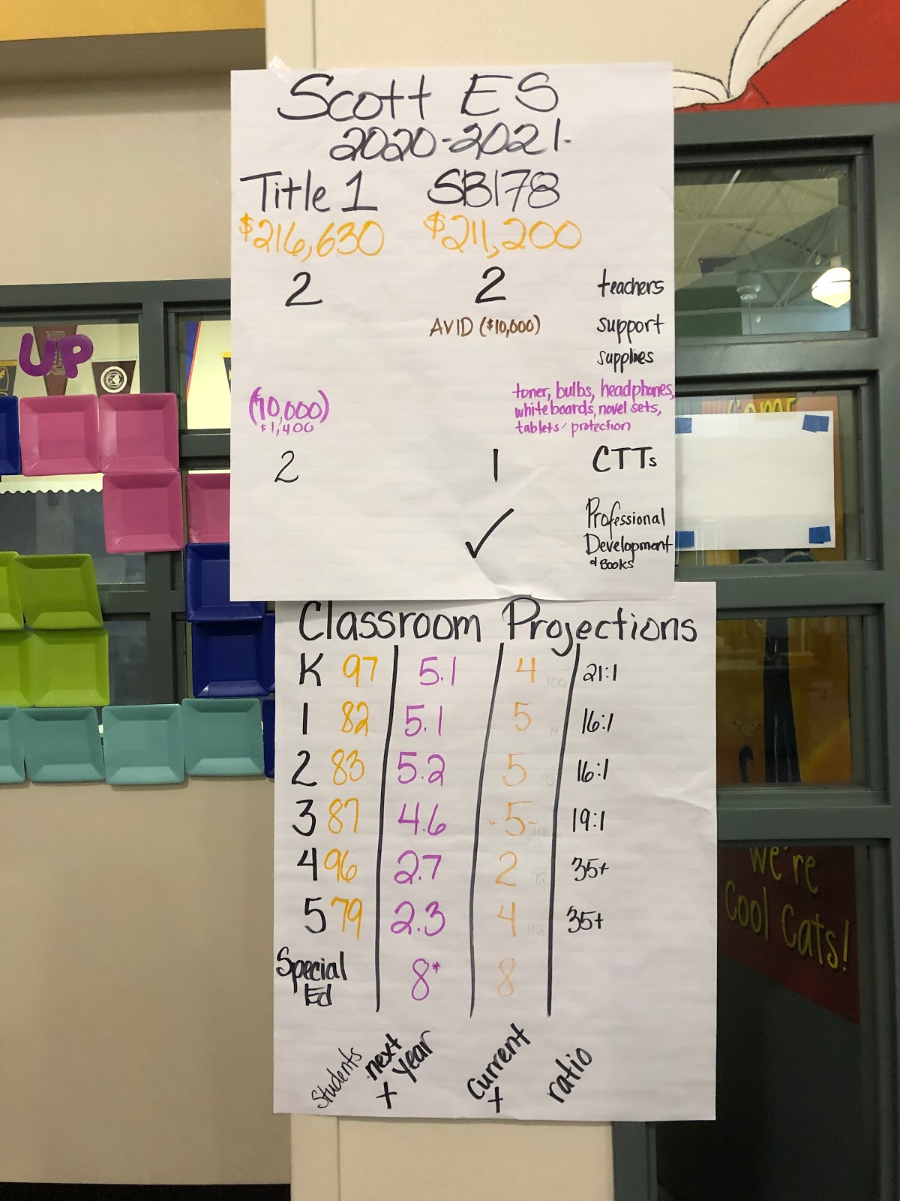

3:00- Ms. Roseman addressed field trips. Keeping in mind that
students need time in the classroom, each grade level had been
offered the opportunity to participate in a field trip. Interests
were to be submitted to administration, prior to signed
obligations.
A parent attendee commented on the very positive experience
her student had on his field trip to Anderson Dairy.
Ms. Roseman continued, making the meeting aware that
changes to Category 4 field trips had been voted on
by the board. Safer field trips.
3:04- Mr. Figgers spoke on the renewal of the Standard Student
Attire for the 2020-2021 school year. J.D. Scott will resubmit
same uniform standard that is currently in place. Ballots will
be mailed out to parents mid March. They will be mailed back
to CCSD office. CCSD will submit results to J.D. Scott E.S. The
results should be available before the end of this school year.
The parent attendee commented her support of the current
SSA.
3:06- Ms. Roseman relayed to the attendees the concern of CCSD
and the Health Department regarding the preponderance
of unlicensed food vendors or food carts on or near school
campuses. CCSD has asked for schools to be vigilant.
3:09- Ms. Mangum shared with the attendees a print out of
School Data for: Imagine Learning Program, Myon, Lexia
and ST Math. There has been positive growth in the use of
these programs. Completing the ST Math program is pro-
moted by giving students activity incentives during Pi week.
Ms. Roseman added that at Scott, math is celebrated during
Pi Day, 3-14 .
3:15- The next School Organizational Team meeting is scheduled for
February 19, 2020. An interim meeting may be held to discuss
the budget.
3:16- Meeting was called to close.

Minutes
Jesse D. Scott
School Organizational Team Meeting
Library
February 14, 2020
2:10 p.m. –4:33p.m.
School Organizational Team Members:

Chair: Diane Mangum-Present
Vice Chair: Jennifer Spigel
Secretary: Gloria Roe
Parlimentarian: Miyonna Jones
Others Present: Jordan Pearce- Teacher

Principal: Dana Roseman-Present
Assistant Principal: Deborah Faltinosky
Parent: Kennedith Marshall
Parent: Jennifer Orpilla

Topics to be Discussed:
- Welcome & Roll Call at 2:10
- School Performance Plan
  - Review and Discussed SPP for 2020-2021 School year.
  - Gave feedback, suggestions to help support SPP and looked at current data.
  - Pearce suggested that we continue doing trainings in AVID, and other school based trainings, ideas for parent engagement, , etc.
  - Discussed teacher efficacy and how we can support teachers.
- Budgets 2020-2021 school year (Title I, Strategic, Etc.)
  - Budgets are the same as last time.
- Parent Nights
  - Looking at different ways to engage parents
  - Engage parents in ways to look at our student;s learning and how they can help their children achieve at a higher level.
  - First change during Literacy Night-Saddle up and Read
    - Parents will come and get a different experience than they had in the past.
    - Teach parents how to work with students at home
    - Get feedback from parents
    - Parents will learn how to read Grade level Map Data
    - Parents will work in MPR to learn two AVID strategies.
    - Students will work in library to practice for the program later that night.
    - The participants can dress up in Western wear and be involved in the contest.

- Next Meeting March 25, 2020 at 2:45pm
- Closed Meeting at 4:33pm,

